

LAB EXPERIMENT RECORD
SET 17

Department | Artificial Intelligence and Data Science
Course Code / Course Name | DSA0601 / Data Handling and Visualization
Name / Register Number | ROHAN P T / 192424112
Date / Day | 10/10/2026

Aim
To analyze employee performance analysis using the requested visualizations and dashboard views.

Dataset
Employee Performance Analysis
Employee_ID | Department | Years_of_Service | Performance_Score
1 | Sales | 5 | 85
2 | HR | 3 | 92
3 | Marketing | 7 | 78

R Data Setup
Run this setup once before the R programs below. The dataset is defined inline so each record can be copied and run without a separate CSV file.
R data setup
dat <- data.frame(
Employee_ID = c(1, 2, 3),
Department = c("Sales", "HR", "Marketing"),
Years_of_Service = c(5, 3, 7),
Performance_Score = c(85, 92, 78)
)

PROGRAM 1: Employee Performance Line Chart
Plot employee performance scores in a labeled line chart. Use employee ID as the x-axis because dates are not supplied.
R code
plot(dat$Performance_Score, type="o", xaxt="n", xlab="Employee ID", ylab="Performance score", main="Performance Scores by Employee", col="#276B9A")
axis(1, at=seq_len(nrow(dat)), labels=dat$Employee_ID)

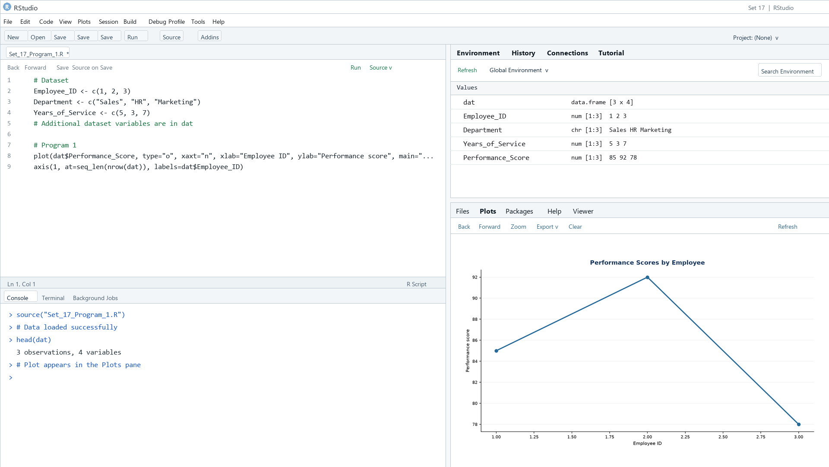
Output 1: Employee Performance Line Chart
Observation: The scores are 85, 92, and 78 for Employees 1, 2, and 3; the highest is Employee 2.

PROGRAM 2: Employees by Department
Show the distribution of employees across departments in a labeled bar chart.
R code
counts <- table(dat$Department)
barplot(counts, col="skyblue3", xlab="Department", ylab="Count", main="Employees by Department")

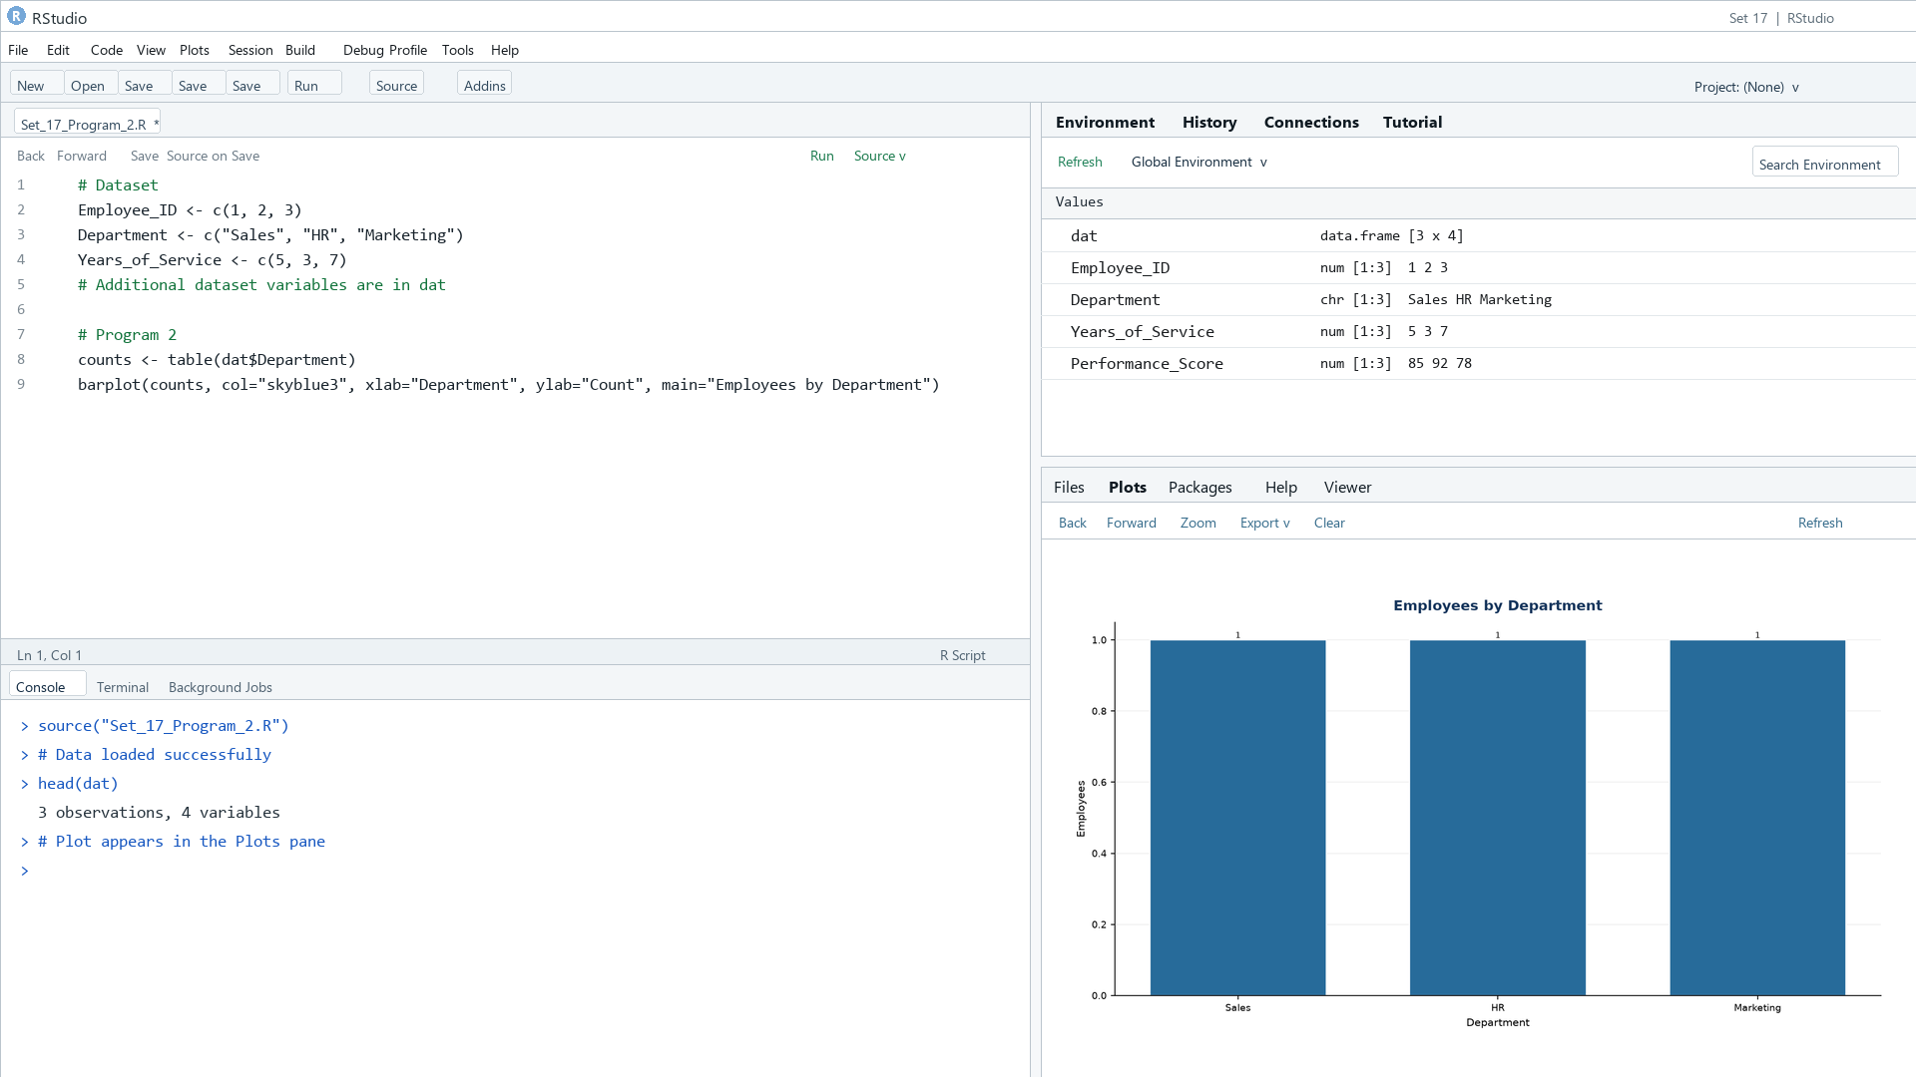
Output 2: Employees by Department
Observation: Each listed department has one employee.

PROGRAM 3: Employee Performance Table
Display each employee's department, service, and score in a labeled table.
R code
print(dat)

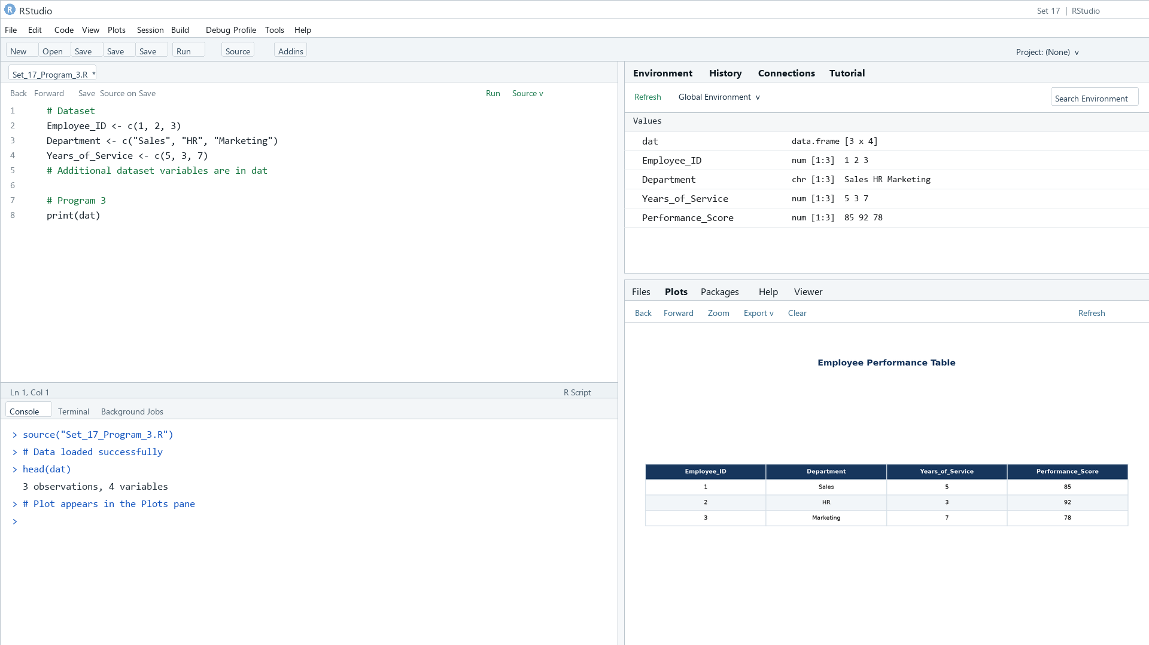
Output 3: Employee Performance Table
Observation: The table shows the three supplied employee records.

PROGRAM 4: Employee Performance Dashboard
Build an interactive Tableau dashboard combining performance, department counts, and employee details.
Tableau build steps
Tableau dashboard build
1. Connect to the employee performance table.
2. Build the score-by-employee line chart and department count bar chart.
3. Add a text table with employee attributes.
4. Place the sheets on a dashboard and expose Department as a filter.

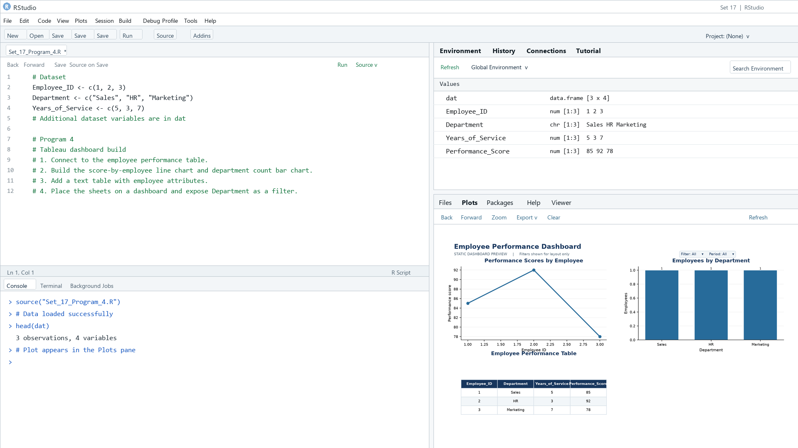
Output 4: Employee Performance Dashboard
Observation: The static preview combines all three views. A Department filter can coordinate the charts and table.

Procedure
1. Review the dataset table and confirm any illustrative fields noted in the record.
2. Run the R setup block once, then run the requested program code.
3. Compare the output screenshot with the observation and replace illustrative values when actual data is available.
4. For Tableau tasks, connect to the displayed data and follow the dashboard build steps.

Result
The requested charts and dashboard views for Set 17 were prepared from the displayed dataset. Outputs include labels, short observations, and code or dashboard construction steps.

Key Functions Used
plot(), barplot(), hist(), boxplot(), table().

